04b. Zendesk - Copilot
Audience: [LOB: Fraud Support]
- Overview
- Agent guide & Feature overview
- Ticket summaries
- Enhanced writing (Tone shift & expand)
- Intelligent triage
- Auto assist
- Suggested first replies
- Merging suggestions for related tickets

Overview
Zendesk Copilot is a suite of AI-powered features built into the Zendesk Agent Workspace. It is designed to reduce manual effort, streamline workflows, and help agents resolve fraud support tickets more efficiently and consistently.
Copilot is an assistive tool - it does not replace agent judgment. Agents remain responsible for reviewing all AI-generated content and ensuring every action, response, and resolution complies with Fraud Support policies and procedures.
⚠️Important Reminder: You Are the Final Decision Maker
Zendesk Copilot is a powerful assistant designed to make your workflow faster and easier, but it is not flawless. AI can occasionally misinterpret complex contexts, making it especially important to exercise human judgment during fraud investigations.
Copilot is designed to support your judgment - not replace it. You are ultimately responsible for every action, response, and resolution applied to a ticket.
Always:
- Double-check AI-generated summaries against the actual ticket conversation.
- Verify that suggested actions align with our internal fraud policies.
- Review AI-drafted responses carefully before sending them.
Think of Copilot as a highly capable assistant that still requires your expert sign-off before any action is taken.
If you identify any major concerns or performance issues with Copilot, raise them immediately with your Team Lead, who can then contact the onshore team.
The following sections provide an overview of the Copilot features available to you, explain how they work, and outline guidelines for using them in your day-to-day workflow.
Common AI errors:
Summarization errors – The AI may omit important information or overemphasize less relevant details.
Policy interpretation errors – The AI may recommend an action that does not fully align with internal policy.
Context errors – The AI may not correctly interpret the full ticket history, especially in long or transferred conversations.
The following video contains an overview of how to use the various translation features within Zendesk: Zendesk Translation Overview

Agent guide & Feature overview

Ticket summaries
Overview | How to use | Agent guidelines
Provides an AI-generated summary of all public and internal comments added to a ticket, allowing you to quickly understand the conversation without reading the entire thread first. | Review the AI-generated summary at the top of the ticket to get up to speed quickly, rather than reading through a lengthy thread of back-and-forth emails.  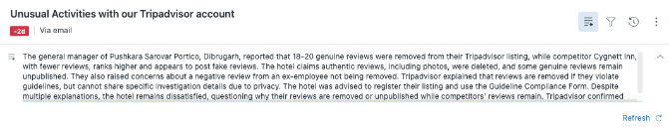 | - Ticket summaries are a major time-saver, especially for escalated or transferred tickets. However, if a case involves highly sensitive or complex transaction details, review the actual ticket thread to ensure no critical data points have been omitted from the summary.  - After reading the summary, review all ticket details to confirm the nature of the ticket. Use the summary to help identify key information, but do not use it as the sole source of information when reviewing the ticket.

Enhanced writing (Tone shift & expand)
Overview | How to use | Agent guidelines
Automatically improves the content of your drafted comments. It can turn brief bullet points into full sentences or adjust the tone of your response. | Type a rough draft or bullet points in the Zendesk composer/text field, highlight the text, and click the AI button.   | - Read through the English updates made by the AI and do not assume it has updated everything perfectly.  - If you use the Make more friendly option, ensure the response is not too informal and still maintains a professional tone.  - It is especially important to confirm that AI has not edited a macro in a way that exposes sensitive information before sending the response.
Available writing options - Integrated Copilot
Option | Description
Expand | Turn short notes into a comprehensive response.
Make more friendly | Softens the tone to sound more conversational.
Make more formal | Shifts the tone to sound highly professional.
Translations | Use the custom prompt field to translate responses or macros into the required language (for example, "Please translate this to Japanese"). You may use this feature to send responses in languages for which translated macros are not available. You do not need to check the translation after entering the prompt. However, you must include the English version of your message in the internal note before responding.
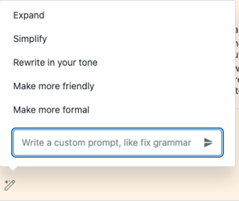

Intelligent triage
Overview | How to use | Agent guidelines
Automatically eliminates manual ticket sorting by analyzing incoming requests using intent detection, language detection, and sentiment analysis to categorize tickets. It can also identify unique details, such as specific product names. | No manual action is required. Intelligent Triage runs in the background to automatically route tickets to the right queue, proactively request missing information from customers, and provide you with instant context. | - A rotation has been created for five agents to work across the User Sourced, Owner Sourced, and English/Global Language views.  - If a ticket is incorrectly sorted, do not move it to another queue. Handle the ticket as you normally would.

Auto assist
Overview | How to use | Agent guidelines
Reads the contents of submitted tickets and suggests the next best steps for resolving them based on our configured procedures. | Review the automatically generated guidance in your workspace. If Auto Assist suggests actions (such as applying a specific tag or sending a recommended response), review the suggestions and approve them to allow Auto Assist to perform those actions on your behalf. | - Auto Assist generates suggested replies using our knowledge base, ticket intent, ticket summary, and generative AI. Suggested replies appear where you normally add an internal comment or public reply (see screenshot below).  - Read the entire suggested response to ensure it is applicable to the ticket and contains no incorrect information.  - You may use this feature to respond in languages for which translated macros are unavailable, provided Auto Assist generates the reply in the end user's language.  - If the suggested response is well suited for the ticket, select Approve to send it. If changes are needed, edit the response before sending.  - Edit suggested responses whenever necessary, as Auto Assist learns from those edits. If you turn Auto Assist off before replying, it will not learn, and the tool will not improve.  - Auto Assist may be paused for the initial response on escalations from Customer Care, as the AI has difficulty with these initial responses.
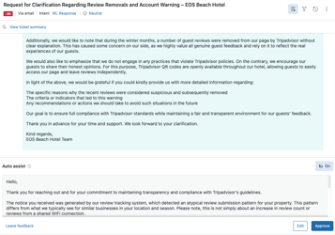

Suggested first replies
Overview | How to use | Agent guidelines
Generates a suggested first response using existing macros and Help Center articles to help you start the conversation. | When you open a new ticket, Copilot generates a suggested first reply. You can apply it as-is, edit it before sending, or discard it and write your own response. | This feature works similar to Auto Assist, but for the initial reply only. As such, it will not be turned on, and Auto Assist will be used for this function.

Merging suggestions for related tickets
Overview | How to use | Agent guidelines
Proactively identifies whether the customer has submitted other tickets within a two-week window before or after the current ticket. | Check the Intelligence section of the ticket's context panel. If related tickets are suggested, review them and merge them if they are correctly identified. | Review the suggested tickets to ensure they are correctly identified before merging them. The suggestions appear in the location shown in the screenshot below.
